**© 2015 – Foxes Team**

<http://process.ws>

**Abstract**

This document describes in detail the process  
which will use to define the Software Architectural Design.

**Process for**

**Architectural Phase**

**Foxes Project**

**Table of Contents**

1. Introduction 3

1.1. Purpose & Scope 3

1.2. Intended Audiences 3

2. Process Objectives 3

3. Process Visual Diagram 4

3.1. Define the Architecture Driver Document 4

3.2. Define the Software Architectural Design 5

4. Process Roles & Responsibilities 5

5. Process Description 6

5.1. Define the Architecture Driver Document 6

5.2. Define the Software Architectural Design 7

5.2.1. Implement the Architectural Design 7

5.2.2. Evaluating the Architectural Design 8

Revision 9

**Table of Figures**

Figure 1 - The overview of Architectural phase 4

Figure 2 - Define the Architecture Driver Document 4

Figure 3 - Define the Software Architectural Design 5

**Table of Tables**

Figure 1 - Intended Audiences 3

Figure 2 - Process Roles & Responsibilities 5

Figure 3 - Analyzing the Architecture Driver 6

Figure 4 - Evaluating the Architecture Driver 6, 7

Figure 5 - Confirm Architecture Driver 7

Figure 6 - Implement the Architectural Design 6, 7

Figure 7 - Evaluating the Architectural Design 7

# Introduction

## Purpose & Scope

This document describes in detail the process – which will use to define the Software Architecture Design.

The process will be started right after the end of Requirement phase, using Software Requirement Specification (SRS) document as the input.

By the name of this process, the final output will be Software Architectural Design (SAD) document.

## Intended Audiences

|  |  |
| --- | --- |
| Audience | Reference Purpose |
| Project Manager | 1. Scheduling & tracking the Architectural phase. 2. Update the Project Plan. |
| Mentor | Reviewing to help Foxes team improve the quality of Architectural phase – as well as the Software Architectural Design. |
| Architectural Leader | Following this process to lead Architectural Engineers in implementing the Software Architectural Design. |
| Architectural Engineer | Following this process to implement the Software Architectural Design. |

Table 1 - Intended Audiences

# Process Objectives

Process of Architectural Phase will:

* Steps to elicit & analyze the Architecture Drivers from gathered Requirements, generate a new document named: Architectural Driver Document (ADD).
* Steps to define & evaluate design based on, correspond to the ADD – it’s about the Software Architectural Design document.

# Process Visual Diagram

The following figure will give you a big picture about activities which will be implemented in the phase of Architectural.

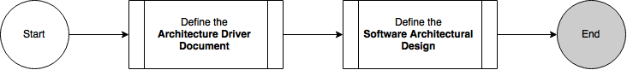

Figure - The overview of Architectural phase.

## Define the Architecture Driver Document

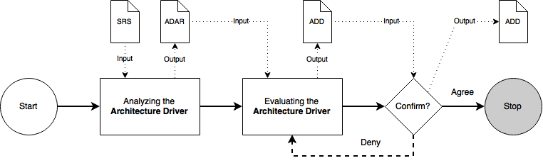

Figure 2 - Define the Architecture Driver Document

Document in this sub-process:

* SRS: Software Requirement Specification
* ADAR: Architecture Driver Analysis Report
* ADD: Architecture Driver Document

## Define the Software Architectural Design

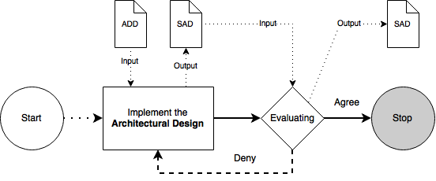

Figure 3 - Define the Software Architectural Design

Document in this sub-process:

* ADD: Architecture Driver Document
* SAD: Software Architectural Design

# Process Roles & Responsibilities

|  |  |
| --- | --- |
| Role | Responsibility |
| Project Manager | * Ensures that requirements engineers and architects have the resources, tools, training and knowledge to work on requirements activities. * Helping to set budget and schedule, gauging progress against established budget and schedule. * Identifying and resolving development-time resource contention. |
| Requirement Leader | * Verifies that requirements are correct, complete and consistent. |
| Architectural Leader | * Identifies integration issues between hardware, software, and systems. * Providing evidence that the architecture satisfies its requirements. |
| Architectural Engineer | * Designs the architecture under the monitoring of Architectural Leader. |

Table - Process Roles & Responsibilities

# Process Description

## Define the Architecture Driver Document

### Analyzing the Architecture Driver

|  |  |
| --- | --- |
| **Required Input** | 1. Software Requirement Specification |
| **Expected Output** | 1. Architecture Driver Analysis Report |
| **Participants** | 1. Requirement Leader (RL) 2. Architectural Leader (AL) 3. Architectural Engineer (AE) |
| 1. Based on the requirements from SRS document, the AEs pick-up all of architecture driver and put it into a new document named: ADAR. **In this step, we don’t need to decide what will be implemented and what won’t.** 2. AL & AE working together to refine & analyze the picked-up architecture driver, included specification it as a Quality Attribute Scenario with the support of RL to make sure that all of requirements are clarified. 3. Refine the final version of ADAR document and move to next step. | |

Table 3 - Analyzing the Architecture Driver

### Evaluating the Architecture Driver

|  |  |
| --- | --- |
| **Required Input** | 1. Architecture Driver Analysis Report |
| **Expected Output** | 1. Architecture Driver Document |
| **Participants** | 1. Project Manager (PM) 2. Requirement Leader (RL) 3. Architectural Leader (AL) |
| 1. The AL & RL working together to define:    1. What Architecture Driver will be bring into the design, why they were chosen and what is the cost of this choosing.    2. What Architecture Driver won’t be bring into the design, why they weren’t chosen and can we put it into the system later? 2. The AL will write down all of decision about every Architecture Driver – which was evaluated in the last step into a new document name: Architecture Driver Document. 3. After making the decision, PM & AL will working together to inspection the document, make sure it got enough quality to be dealing with the customer. | |

Table 4 - Evaluating the Architecture Driver

### Confirm

|  |  |
| --- | --- |
| **Required Input** | 1. Architecture Driver Document |
| **Expected Output** | 1. Architecture Driver Document (Confirmed by Customer) |
| **Participants** | 1. Customer (CS) 2. Project Manager (PM) 3. Architecture Leader (AL) |
| 1. The PM contacts CS to hold a meeting about the Architecture Driver. 2. In the meeting of CS, PM and AL:    1. AL present the Architecture Driver which were analyzed and evaluated based on the Architecture Driver Document.    2. PM present the pros and cons of the decision, included the cost of choosing this or that Architecture Driver.   *E.g. To implement this Architecture Driver, you will need to buy a super powerful server computer, it may cost you about $1000 in the early stage of this project, etc.*   1. The CS will make the decision that will they agree or deny the evaluating    1. Case of agree, the CS will sign off into the current Architecture Driver Document and confirm to provided everything that the project needs about resources, costs, etc. to implement chosen Architecture Driver.    2. Case of disagree, the PM & AL will re-work to find out a new solution based on the given problems of CS (not enough effort, not enough cost, etc.) and re-holding this meeting one more time. | |

Table 5 – Confirm Architecture Driver

## Define the Software Architectural Design

## Implement the Architectural Design

|  |  |
| --- | --- |
| **Required Input** | 1. Architecture Driver Document |
| **Expected Output** | 1. Software Architectural Design |
| **Participants** | 1. Architectural Leader (AL) 2. Architectural Engineer (AE) |
| 1. Implement the Architecture design. Included all of three required perspective and related information. | |

Table 6 – Implement the Architectural Design

## Evaluating the Architectural Design

|  |  |
| --- | --- |
| **Required Input** | 1. Software Architectural Design |
| **Expected Output** | 1. Software Architectural Design (Confirmed by Customer) |
| **Participants** | 1. Customer (CS) 2. Project Manager (PM) 3. Architecture Leader (AL) |
| 1. PM will conduct the meeting to AL and CS evaluates the Architect Design. 2. In the meeting, AL will introduce to CS about Architecture Driver materials. Evaluate the list of issues uncovered in architecture evaluation and determine how each issue will be addressed. 3. After discussion:    1. Case of approve, the CS will sign off into the current Architecture Design Document and end process.    2. Case of deny, the PM & AL will re-work to find out a new solution based on the given problems of CS and must to implement Architectural Design again. | |

Table 7 – Evaluating the Architectural Design

# Revision

|  |  |  |  |
| --- | --- | --- | --- |
| # | Date | Editor | Description |
| 4 | Aug 20th, 2015 | Tỷ Trần | * Documentation about the Process for Architectural |
| 3 | Aug 4th, 2015 | Nguyên Đinh | * Update the description. (Cont) |
| 2 | Aug 1st, 2015 | Nguyên Đinh | * Update the description. |
| 1 | Jul 28th, 2015 | Nguyên Đinh | * Initial Release |